



**ACL Tear**

The ACL is the most commonly injured knee ligament. Sports injuries usually cause ACL tears. If you tear your ACL, you’ll probably need surgery to repair it. Most people who tear their ACL make a full recovery and resume playing sports with no long-term consequences. The recovery time for a torn ACL is usually six to nine months.

**Overview**

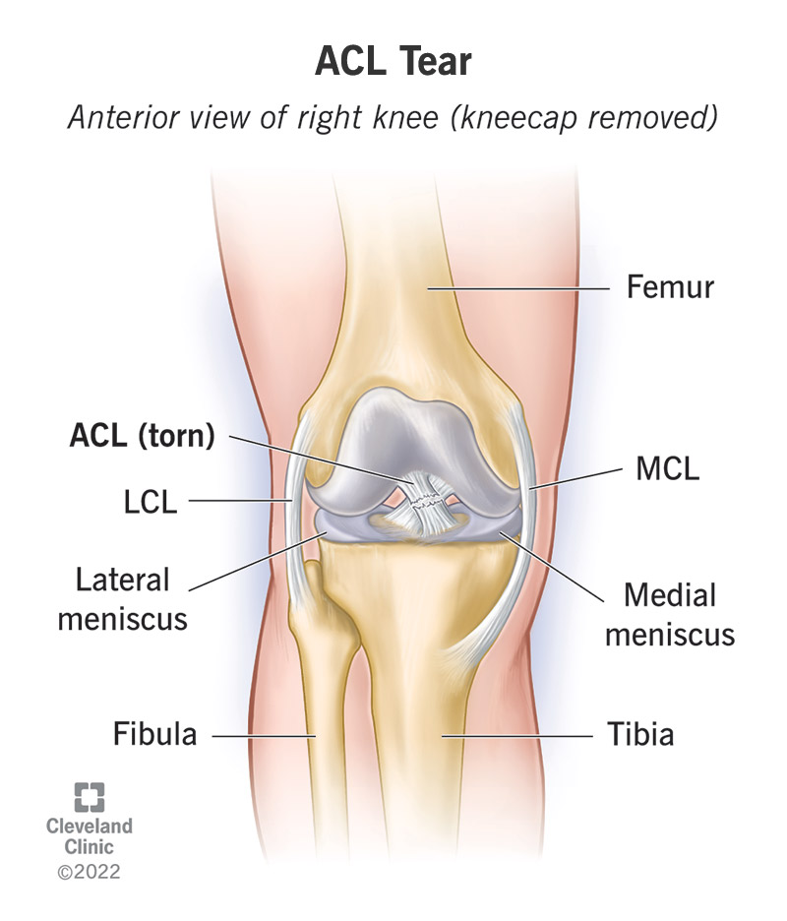Anything that puts enough force on your knee to bend or twist it farther than its natural limit can tear your ACL.

**What is an ACL tear?**

An ACL tear is an injury to the anterior cruciate ligament (ACL) in your knee.

The ACL is one of your [knee ligaments](https://my.clevelandclinic.org/health/body/21596-knee-ligaments). It connects your thigh bone ([femur](https://my.clevelandclinic.org/health/body/22503-femur)) to your shin bone ([tibia](https://my.clevelandclinic.org/health/body/23026-tibia)). You have one ACL in each knee. It forms an “X” shape inside your knee with your posterior cruciate ligament (PCL). The ACL is closer to the front of your knee. The PCL is closer to the back of your knee.

Your ACL is like a strap that connects your bones and prevents your knee from bending or rotating too much. Anything that puts enough force on your knee to bend or twist it farther than its natural limit can injure or tear your ACL.

ACL tears are a common injury, especially among athletes. Visit a healthcare provider if your knee hurts, particularly if the pain started after an injury or physical activity.

**Types of ACL injuries**

Healthcare providers usually grade ACL injuries and tears. These grades are a quick way to describe the extent of your injury. ACL injury grades range from one (the least severe) to three (the most severe):

* **Grade one:** The injury stretched your ACL enough to damage it, but it’s still in one piece and holding your knee bones together.
* **Grade two:** The injury stretched your ACL so much that it was partially torn and loosened.
* **Grade three:** A complete tear — your ACL is in two pieces.

**What does an ACL tear feel like?**

Most people know the moment they tear their ACL. [Sports injuries](https://my.clevelandclinic.org/health/diseases/22093-sports-injuries) and other traumas that tear your ACL are usually obvious enough that you can say exactly when it happened.

People who experience an ACL tear usually feel or hear a pop in their knee. Your knee might give out (feel unstable and weak). ACL tears can be very painful, but some people only feel small discomfort. Visit a provider if you injured your knee — especially if you heard or felt a popping.

**How common are ACL injuries?**

ACL injuries and tears are very common. The ACL is the most commonly injured knee ligament. Experts estimate that between 100,000 and 200,000 people in the U.S. tear an ACL each year.

**Symptoms and Causes**

**What are ACL tear symptoms?**

The most common ACL tear symptoms include:

* Feeling or hearing a pop in your knee.
* Swelling.
* Pain (especially when you try to put weight on your knee).
* Weakness or feeling like your knee has given out.
* Losing your range of motion (how far you can move your knee).

**What causes ACL tears?**

Anything that puts too much force on your knee can tear your ACL. ACL tears happen when your knee moves or twists more than it naturally can.

The most common causes of ACL tears include:

* Sports injuries.
* Car accidents.
* Falls.

**ACL tear risk factors**

Anyone can experience an ACL tear. They’re much more common among athletes, especially those who play sports that involve suddenly stopping, twisting or changing directions. Some sports that cause frequent ACL tears include:

* Soccer.
* Football.
* Basketball.
* Gymnastics.
* Lacrosse.

**What are the complications of an ACL tear?**

The injuries that cause ACL tears can damage other parts of your knee, too.

You might damage or tear your other knee ligaments during an ACL tear, including your:

* Medial collateral ligament (MCL).
* Lateral collateral ligament (LCL).
* Posterior cruciate ligament (PCL).

Other injuries that can occur at the same time as an ACL tear include:

* [Bone fractures](https://my.clevelandclinic.org/health/diseases/15241-bone-fractures).
* [Meniscus tears](https://my.clevelandclinic.org/health/diseases/17219-torn-meniscus).
* [Muscle strains](https://my.clevelandclinic.org/health/diseases/22336-muscle-strains).

**Diagnosis and Tests**

**How are ACL tears diagnosed?**

A healthcare provider will diagnose an ACL tear with a [physical exam](https://my.clevelandclinic.org/health/diagnostics/17366-physical-examination) and some tests. They’ll ask you about your symptoms and look at your knee. Tell your provider what you were doing right before you hurt your knee and when you first noticed symptoms.

Your provider might perform some movements or motions with your knee and leg. These tests might feel uncomfortable. Tell your provider if any position or motion hurts or makes your symptoms worse.

You’ll probably need at least one of a few imaging tests, including:

* [X-rays](https://my.clevelandclinic.org/health/diagnostics/21818-x-ray).
* A [computed tomography (CT) scan](https://my.clevelandclinic.org/health/diagnostics/4808-ct-computed-tomography-scan).
* [Magnetic resonance imaging (MRI)](https://my.clevelandclinic.org/health/diagnostics/4876-magnetic-resonance-imaging-mri).

**Management and Treatment**

**How are ACL tears treated?**

Treatments can vary depending on your ACL tear grade and any other damage inside your knee.

Don’t play sports or do any activity that can put more stress on your knee. Follow the [RICE method](https://my.clevelandclinic.org/health/treatments/rice-method) as soon as you notice pain or other symptoms:

* **Rest**: Avoid the activity that caused your injury. Don’t overuse your knee while it heals.
* **Ice**: Apply a cold compress or ice packs wrapped in a thin towel to your knee for 15 minutes at a time, a few times a day.
* **Compression**: You can wrap your knee in an elastic bandage to help reduce swelling.
* **Elevation**: Prop your knee and leg up above the level of your heart as often as you can.

Your provider will suggest treatments to manage your pain and other symptoms. You might need:

* Crutches.
* A brace that holds your knee in place.
* Over-the-counter (OTC) pain medicine like [NSAIDs](https://my.clevelandclinic.org/health/drugs/11086-non-steroidal-anti-inflammatory-medicines-nsaids) (nonsteroidal anti-inflammatory drugs) or acetaminophen.
* Physical therapy.

**Can an ACL tear heal on its own?**

A torn ACL can’t heal on its own, but it’s possible to live with it (especially if you have a low-grade tear). But if you’re an athlete or want to return to physical activity, you’ll need surgery to repair your ACL. Most people choose to have an ACL tear surgically repaired.

**ACL tear surgery**

Surgery to repair damage in your knees is usually an outpatient procedure, which means you can go home the same day. Your surgeon will perform a [knee arthroscopy](https://my.clevelandclinic.org/health/treatments/17153-knee-arthroscopy), a minimally invasive technique to repair the tear inside your knee. Ask your surgeon what to expect.

**Prevention**

**How can I prevent a torn ACL?**

There might not be any way to prevent an ACL tear, especially if you’re an athlete. Sports injuries and accidents you can’t plan for usually cause ACL tears.

During sports or other physical activities:

* Wear the proper protective equipment.
* Don’t “play through the pain” if your knee hurts during or after physical activity.
* Give your body time to rest and recover after intense activity.
* Stretch and warm up before playing sports or working out.
* Cool down and stretch after physical activity.
* Offseason knee and lower body strengthening programs can help prepare your knee joints for the stress a sports season puts on them.

Follow these general safety tips to reduce your risk of an injury:

* Avoid planting your foot and pivoting over your knee. This is a common way athletes injure their ACL and meniscus.
* Make sure your home and workspace are free from clutter that could trip you or others.
* Always use the proper tools or equipment at home to reach things. Never stand on chairs, tables or countertops.
* Use your cane or walker if you have difficulty walking or have an increased risk of falls.

**Outlook / Prognosis**

**How long does it take to recover from a torn ACL?**

It usually takes six to nine months to recover from a torn ACL. Competitive athletes may need a little longer than this to heal fully before they’re cleared to return to their sport.

Your provider will tell you when you can resume physical activities. Don’t return to playing sports or working out before your provider says it’s safe. If you resume activities before your ACL heals, you’re more likely to re-injure it.

**Living With**

**Can you walk if your ACL is torn?**

Some people can walk with a torn ACL. But don’t force yourself to move or use your knee if it hurts. Visit a healthcare provider if you feel pain or have other knee injury symptoms. Putting more stress on your injured ACL can make a small tear worse.

**When should I see my healthcare provider?**

Visit a healthcare provider as soon as possible after you injure your knee. Talk to your provider if you notice new symptoms or the pain is getting worse.

Go to the emergency room if you experience trauma like a car accident or serious fall. Traumas sometimes cause other injuries you may not notice right away.

**What questions should I ask my doctor?**

* Do I have a torn ACL or another injury?
* What grade is the tear?
* Should I get surgery?
* How long will I need to wait before working out or playing sports again?
* What’s the risk that I tear the same ACL again in the future?

**Additional Common Questions**

**Will an ACL tear happen again?**

There’s a small chance you’ll tear the same ACL again in the future, even if you have surgery to repair it. Fewer than 10% of people who have a torn ACL tear that same ACL again. Talk to your provider or surgeon about what to expect.

**Is an ACL tear “career-ending” for an athlete?**

Most ACL tears aren’t career-ending. Just make sure you don’t rush your recovery. Most people who experience a torn ACL can return to their sport with no long-term consequences. Rehabilitation after your surgery is the best way to restore your knee’s strength and flexibility. You’ll need to rehab your knee over time before you can return to your sport.

Ask your provider or surgeon if it’s safe for you to play the same sport again, and when you can resume practice or training.

**A note from Cleveland Clinic**

ACL tears are one of the most common knee injuries athletes experience. It can be extremely frustrating to miss months of practice, games or training sessions, but don’t rush your recovery. If you need surgery to repair your ACL, you should be able to return to the field or court as soon as your knee has healed.

Don’t force yourself to use your knee if it’s hurt. Extra stress can make a lower grade ACL tear worse. Visit a provider as soon as you injure your knee or feel pain.

